Parallelogram Opposite Sides Theorem
# Source: AI Source: Provided by: [Data Path: Persons Table -> ID Column: 1, Name_En Column: Motasem Essam] -> From: [ChatGPT] on [7/25/2026]
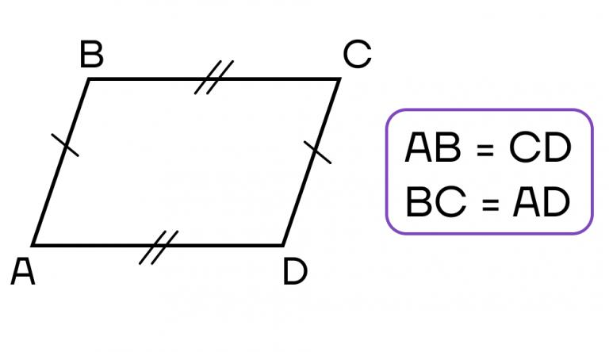
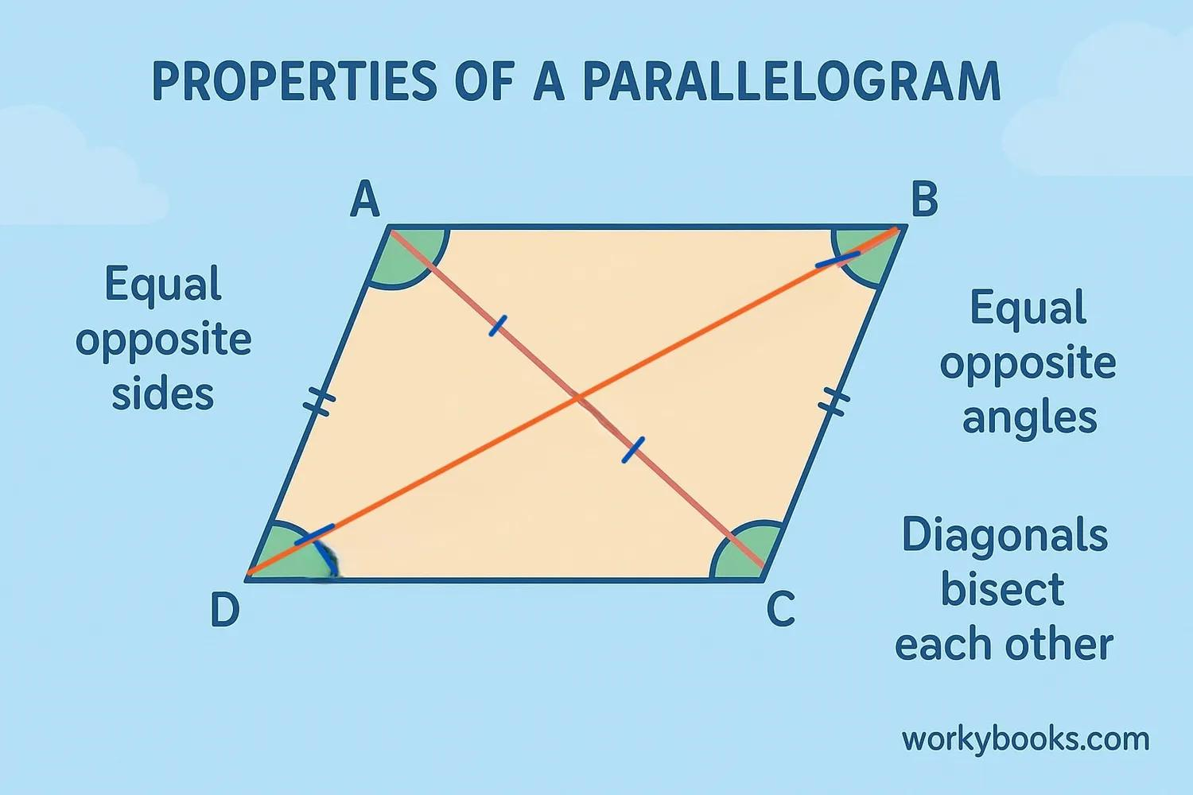
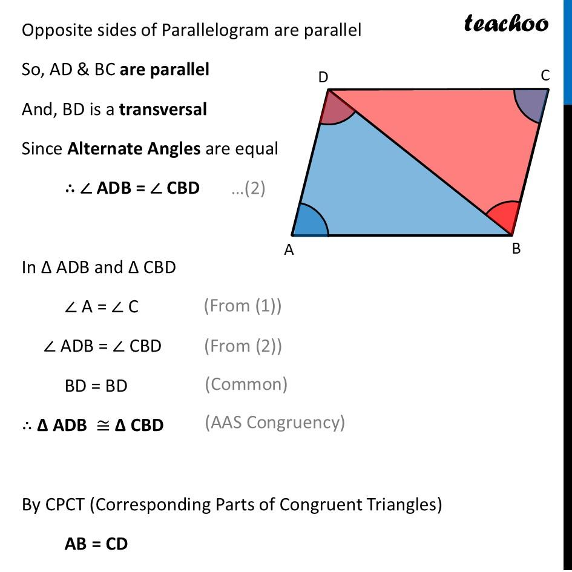
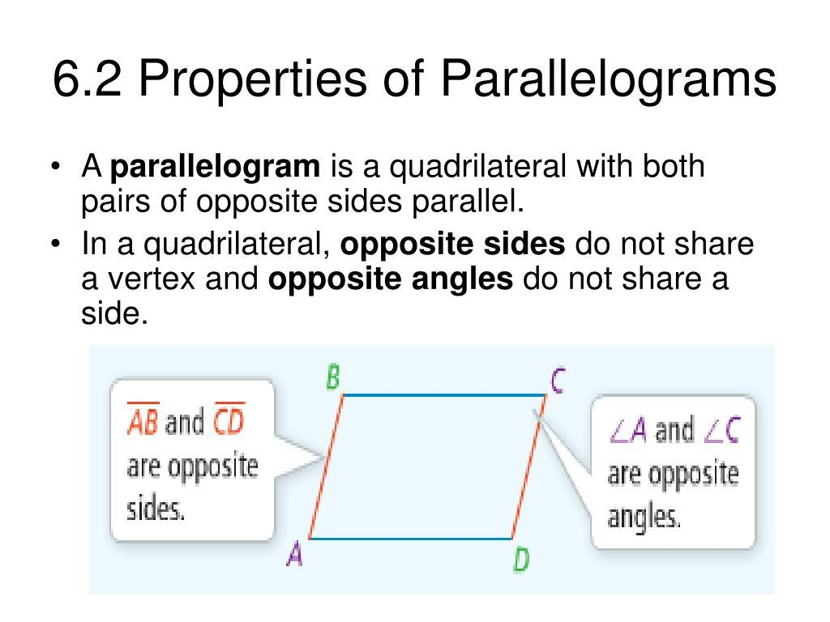

Definition
# Source: AI Source: Provided by: [Data Path: Persons Table -> ID Column: 1, Name_En Column: Motasem Essam] -> From: [ChatGPT] on [7/25/2026]
The Parallelogram Opposite Sides Theorem states:
The opposite sides of a parallelogram are both parallel and congruent.
For parallelogram $ABCD$:
$$\boxed{AB∥CD}$$
and
$$\boxed{BC∥AD}$$
Also:
$$\boxed{AB=CD}$$
and
$$\boxed{BC=AD}$$

Diagram
# Source: AI Source: Provided by: [Data Path: Persons Table -> ID Column: 1, Name_En Column: Motasem Essam] -> From: [ChatGPT] on [7/25/2026]
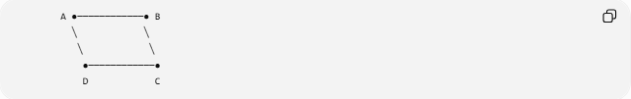
A ●────────────● B
╲ ╲
╲ ╲
●────────────●
D C
For parallelogram $ABCD$:
- $AB$and $CD$are opposite sides.
- $BC$and $AD$are opposite sides.
Therefore:
$$AB∥CD \\ BC∥AD$$
and:
$$AB≅CD \\ BC≅AD$$

Theorem Statement
# Source: AI Source: Provided by: [Data Path: Persons Table -> ID Column: 1, Name_En Column: Motasem Essam] -> From: [ChatGPT] on [7/25/2026]
If $ABCD$is a parallelogram, then:
$$\boxed{AB∥CD, BC∥AD}$$
and:
$$\boxed{AB≅CD, BC≅AD}$$
In terms of lengths:
$$\boxed{AB=CD, BC=AD}$$

Given and Prove

Given
# Source: AI Source: Provided by: [Data Path: Persons Table -> ID Column: 1, Name_En Column: Motasem Essam] -> From: [ChatGPT] on [7/25/2026]
$ABCD$is a parallelogram.
Prove
$$AB≅CD$$
and:
$$BC≅AD$$

Proof
# Source: AI Source: Provided by: [Data Path: Persons Table -> ID Column: 1, Name_En Column: Motasem Essam] -> From: [ChatGPT] on [7/25/2026]
Draw diagonal:
$$\overset{‾}{AC}$$
This divides the parallelogram into two triangles:
$$△ABC$$
and:
$$△CDA$$
Because opposite sides of a parallelogram are parallel:
$$AB∥CD$$
and:
$$BC∥AD$$
Using $AC$as a transversal:
$$∠BAC≅∠DCA$$
because they are alternate interior angles.
Also:
$$∠BCA≅∠DAC$$
because they are alternate interior angles.
Furthermore:
$$AC≅AC$$
by the Reflexive Property.
Therefore:
$$△ABC≅△CDA$$
by:
$$\boxed{\text{ASA}}$$
Corresponding sides of congruent triangles are congruent:
$$\boxed{AB≅CD}$$
and:
$$\boxed{BC≅AD}$$
Therefore, the opposite sides of a parallelogram are congruent.

Why the Sides Are Parallel
# Source: AI Source: Provided by: [Data Path: Persons Table -> ID Column: 1, Name_En Column: Motasem Essam] -> From: [ChatGPT] on [7/25/2026]
Parallelism is actually part of the definition of a parallelogram.
A parallelogram is a quadrilateral with both pairs of opposite sides parallel:
$$AB∥CD \\ BC∥AD$$
The theorem establishes the additional important property that these opposite sides are also equal in length.
Thus:
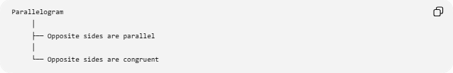
Parallelogram
│
├── Opposite sides are parallel
│
└── Opposite sides are congruent

Coordinate Representation
# Source: AI Source: Provided by: [Data Path: Persons Table -> ID Column: 1, Name_En Column: Motasem Essam] -> From: [ChatGPT] on [7/25/2026]
Let:
$$A=\left(x_{1} , y_{1}\right) \\ B=\left(x_{2} , y_{2}\right) \\ C=\left(x_{3} , y_{3}\right) \\ D=\left(x_{4} , y_{4}\right)$$
For a parallelogram:
$$\vec{AB}=\vec{DC}$$
and:
$$\vec{BC}=\vec{AD}$$
Therefore:
$$\boxed{B-A=C-D}$$
and:
$$\boxed{C-B=D-A}$$
This shows both the parallelism and equal lengths of the opposite sides.

Vector Proof
# Source: AI Source: Provided by: [Data Path: Persons Table -> ID Column: 1, Name_En Column: Motasem Essam] -> From: [ChatGPT] on [7/25/2026]
The vector from $A$to $B$is:
$$\vec{AB}=B-A$$
The vector from $D$to $C$is:
$$\vec{DC}=C-D$$
For a parallelogram:
$$\boxed{\vec{AB}=\vec{DC}}$$
Therefore:
$$∣\vec{AB}∣=∣\vec{DC}∣$$
so:
$$AB=CD$$
Similarly:
$$\boxed{\vec{BC}=\vec{AD}}$$
giving:
$$BC=AD$$

Example
# Source: AI Source: Provided by: [Data Path: Persons Table -> ID Column: 1, Name_En Column: Motasem Essam] -> From: [ChatGPT] on [7/25/2026]
Suppose parallelogram $ABCD$has:
$$AB=12\text{ cm}$$
and:
$$BC=7\text{ cm}$$
By the Opposite Sides Theorem:
$$CD=AB=12\text{ cm}$$
and:
$$AD=BC=7\text{ cm}$$
Therefore:
$$\boxed{CD=12\text{ cm}} \\ \boxed{AD=7\text{ cm}}$$

Perimeter Consequence
# Source: AI Source: Provided by: [Data Path: Persons Table -> ID Column: 1, Name_En Column: Motasem Essam] -> From: [ChatGPT] on [7/25/2026]
Because opposite sides are congruent:
$$AB=CD$$
and:
$$BC=AD$$
the perimeter is:
$$P=AB+BC+CD+DA$$
Therefore:
$$\boxed{P=2\left(AB+BC\right)}$$
Example
If:
$$AB=10$$
and:
$$BC=6$$
then:
$$P=2\left(10+6\right) \\ \boxed{P=32}$$

Area Connection
# Source: AI Source: Provided by: [Data Path: Persons Table -> ID Column: 1, Name_En Column: Motasem Essam] -> From: [ChatGPT] on [7/25/2026]
If the base is $b$and perpendicular height is $h$, the area is:
$$\boxed{A=bh}$$
The congruence of opposite sides means either pair can serve as a corresponding base pair, provided the appropriate perpendicular height is used.

Converse Relationship
# Source: AI Source: Provided by: [Data Path: Persons Table -> ID Column: 1, Name_En Column: Motasem Essam] -> From: [ChatGPT] on [7/25/2026]
There is also a useful converse theorem:
If both pairs of opposite sides of a quadrilateral are congruent, then the quadrilateral is a parallelogram.
If:
$$AB≅CD$$
and:
$$BC≅AD$$
then:
$$ABCD$$
is a parallelogram.
This is different from the original theorem:
Original theorem
$$\boxed{\text{Parallelogram}⇒\text{opposite sides congruent}}$$
Converse
$$\boxed{\text{opposite sides congruent}⇒\text{Parallelogram}}$$

Comparison with Special Parallelograms
# Source: AI Source: Provided by: [Data Path: Persons Table -> ID Column: 1, Name_En Column: Motasem Essam] -> From: [ChatGPT] on [7/25/2026]
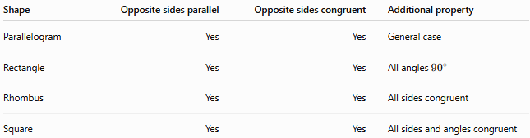
Shape | Opposite sides parallel | Opposite sides congruent | Additional property
Parallelogram | Yes | Yes | General case
Rectangle | Yes | Yes | All angles ${90}^{∘}$
Rhombus | Yes | Yes | All sides congruent
Square | Yes | Yes | All sides and angles congruent
Therefore, the Opposite Sides Theorem applies to all of these shapes because they are all parallelograms.

Important Properties
# Source: AI Source: Provided by: [Data Path: Persons Table -> ID Column: 1, Name_En Column: Motasem Essam] -> From: [ChatGPT] on [7/25/2026]
- Every parallelogram has two pairs of opposite sides.
- Each pair of opposite sides is parallel:
$$AB∥CD \\ BC∥AD$$
- Each pair of opposite sides is congruent:
$$AB=CD \\ BC=AD$$
- Opposite sides have equal lengths.
- Opposite sides have the same direction when represented by corresponding vectors.
- The theorem can be proven using congruent triangles.
- The theorem applies to rectangles, rhombi, and squares because they are special parallelograms.

Key Points
# Source: AI Source: Provided by: [Data Path: Persons Table -> ID Column: 1, Name_En Column: Motasem Essam] -> From: [ChatGPT] on [7/25/2026]
$$\boxed{AB∥CD} \\ \boxed{BC∥AD} \\ \boxed{AB=CD} \\ \boxed{BC=AD}$$
The essential statement is:
The opposite sides of a parallelogram are parallel and congruent.

Conclusion
# Source: AI Source: Provided by: [Data Path: Persons Table -> ID Column: 1, Name_En Column: Motasem Essam] -> From: [ChatGPT] on [7/25/2026]
The Parallelogram Opposite Sides Theorem establishes one of the fundamental properties of parallelograms: each pair of opposite sides has both equal length and parallel direction. This property is central to proving other parallelogram theorems and solving problems involving lengths, perimeter, vectors, coordinates, and congruent triangles.

